Xavor Bootcamp Talk with Amir Rehmani

# Submitted by: Muhammad Kabir Ahmad

# Start of Talk:

It starts with what was the benefits for people to being in healthcare field , and then describes its pons and how you can engage yourself in the center of health field

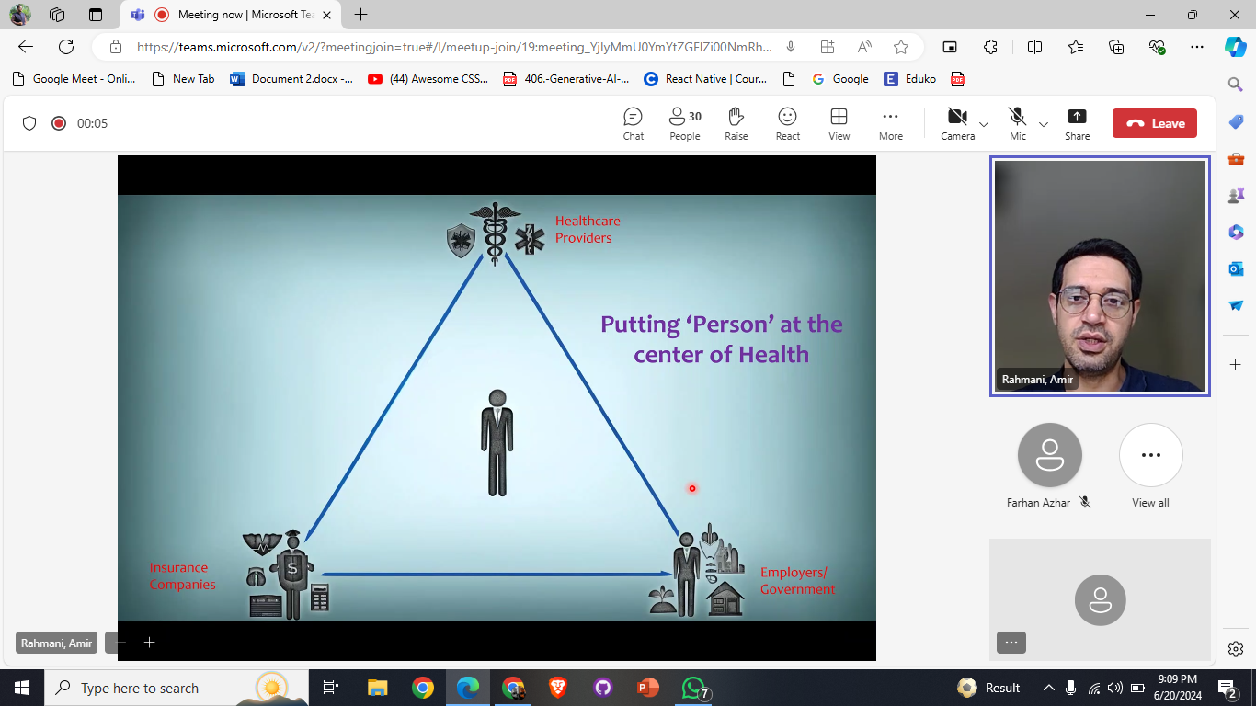

# Engaging with healthcare digital Tools

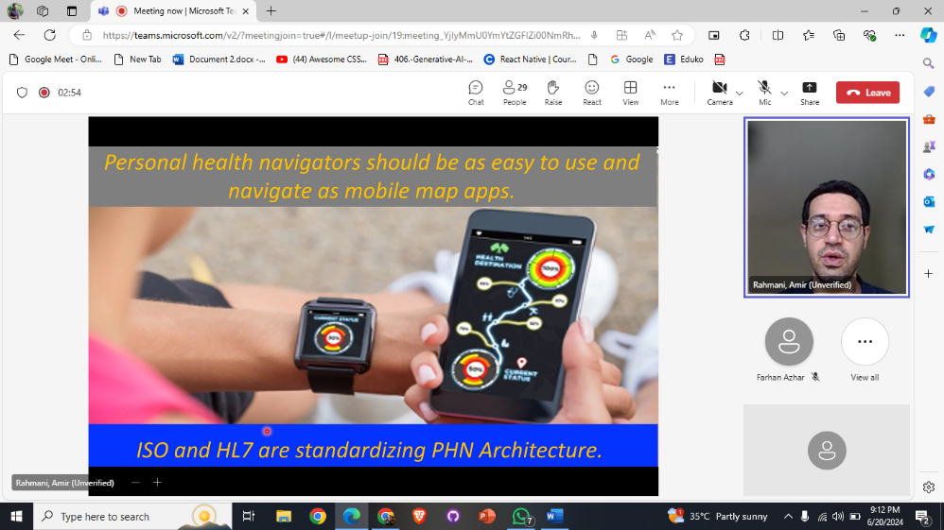In this part , he describes how much ease this era has provided us to engage in prediction of any health related scenario with digital gadgets.

In which , he describes about **How Personal health navigators should be as easy to use and navigate as mobile apps.**

# Cybernetic Personal Health Navigation Model

As Highlighted with in the image, it starts with the highlighted Portion, that consists if a pipeline that describes as:

**“Collection of Relevant data** is the first task , after that the **estimation** on current health state comes that further go towards **Guidance** from the professionals in this field. That further lead towards **Goal**.”

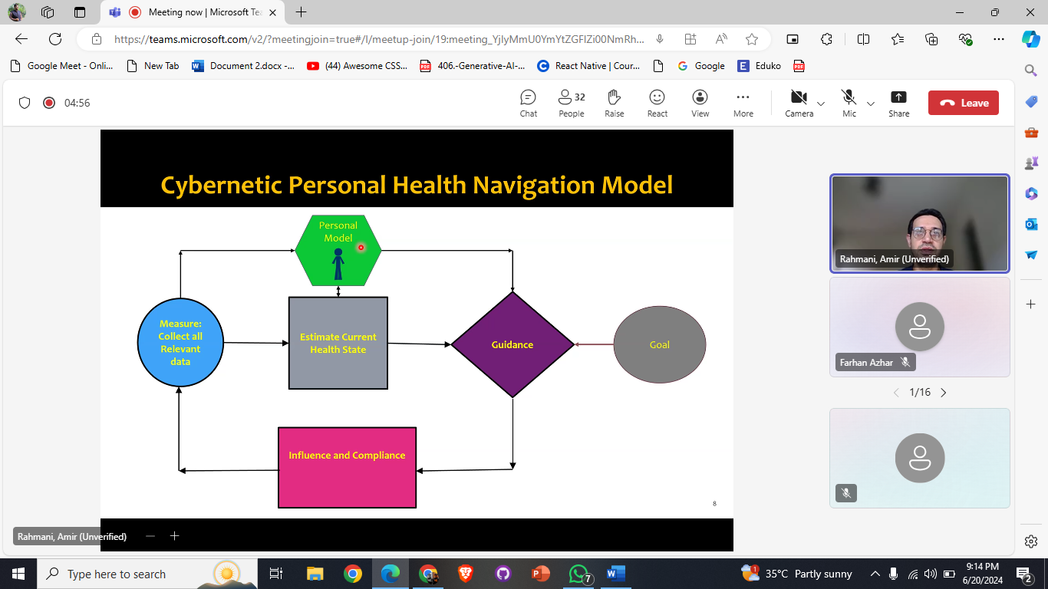

## Describing of health scenarios related to past history of disease

This concerns with the need of health care field importance , by describing the Health effecting scenarios that includes.. Cancer, COVID-19 and others as shown.

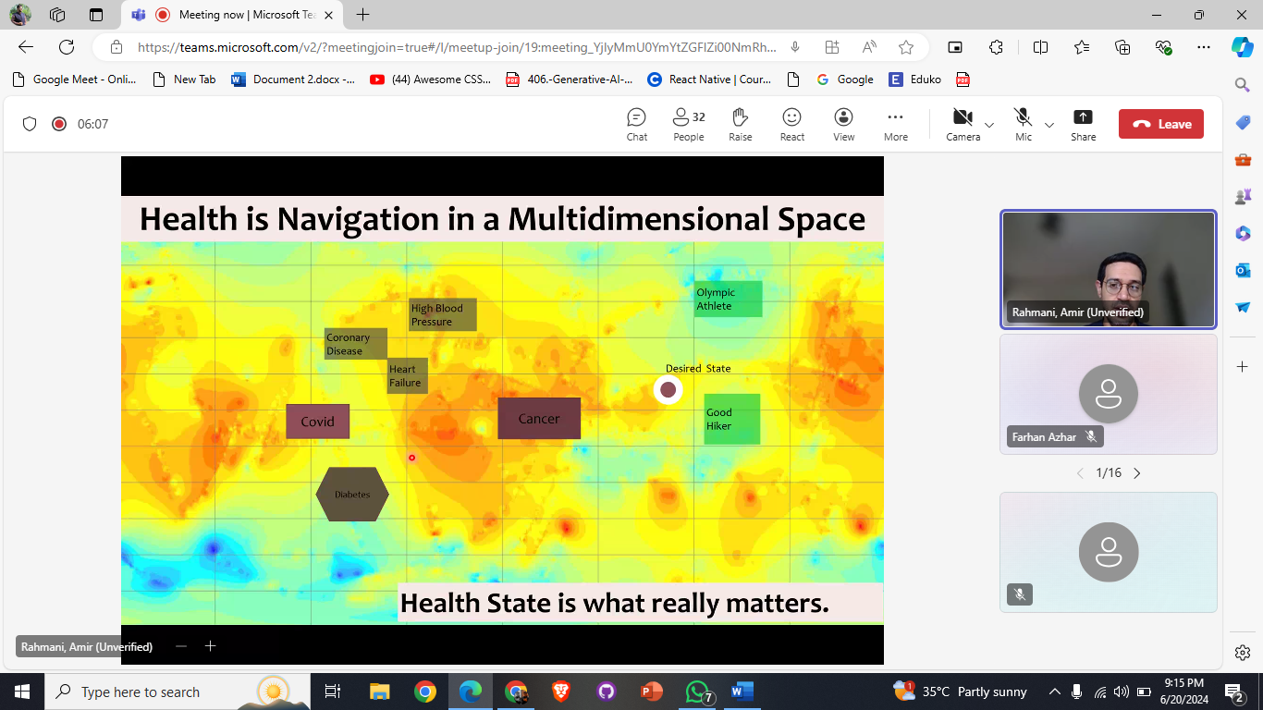

# Component Of Health Navigator

In which , He Describes about some case scenario of how the new navigators works (flow of them that can be seen in image).

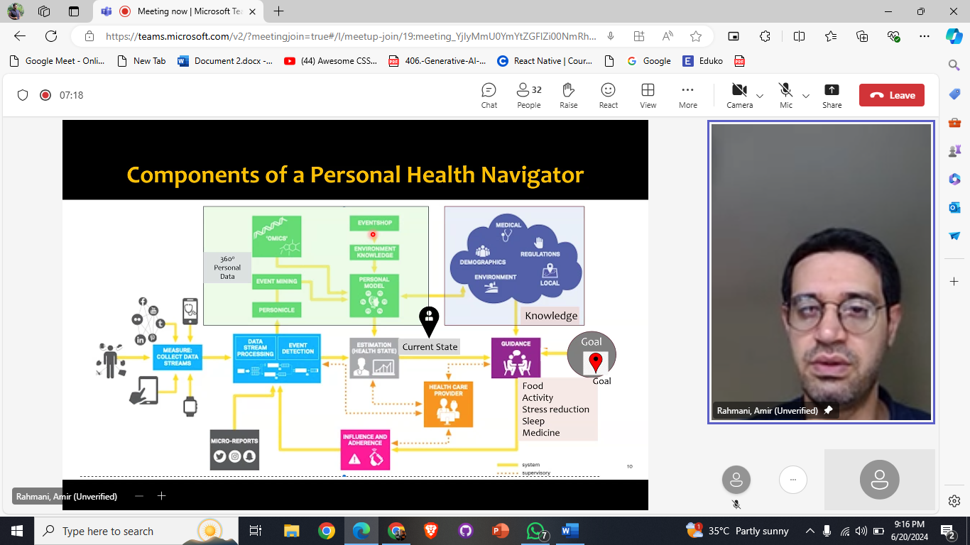

After that he explained some Techniques of How we can Empower AI in this health care domain that can be shown as :

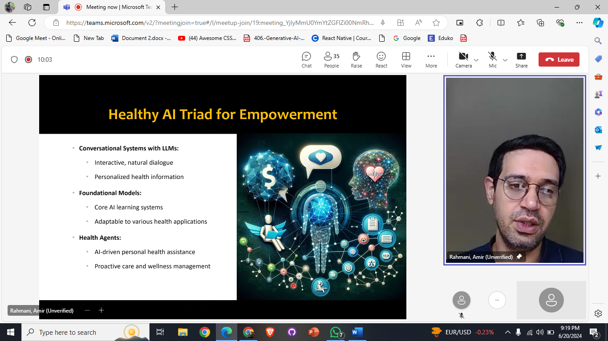

# Book Recommendation

He recommended a Book named as **“ Foundation Metrics for Health Care”**

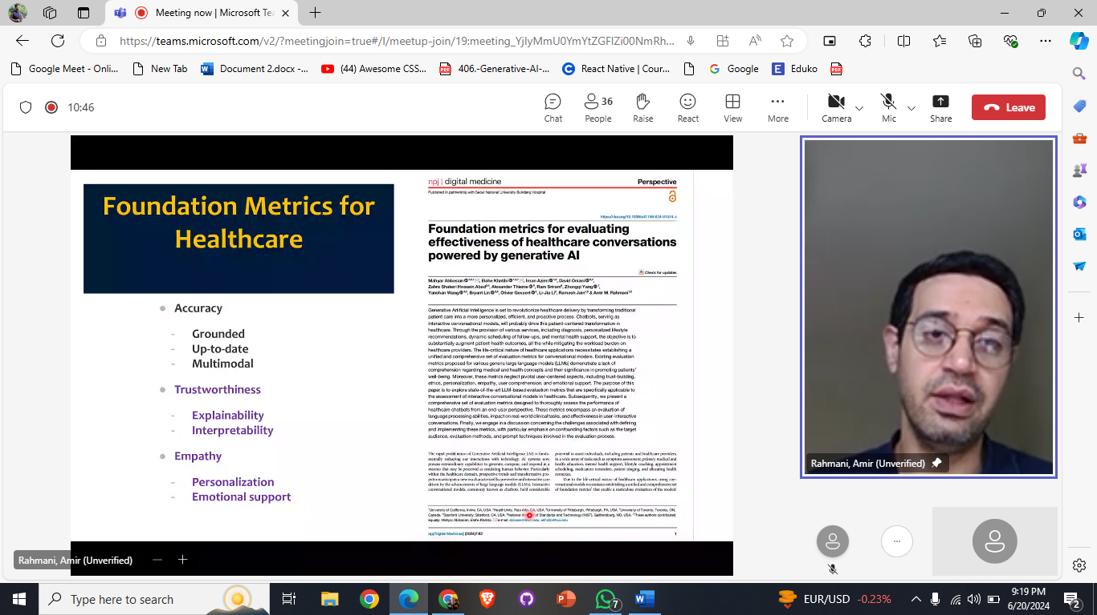

# Evaluation Process and Goal

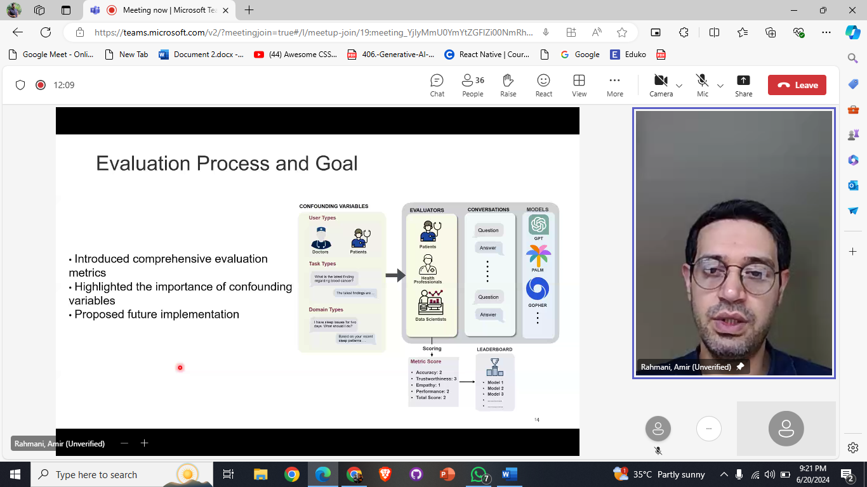

# Proposed Metrics

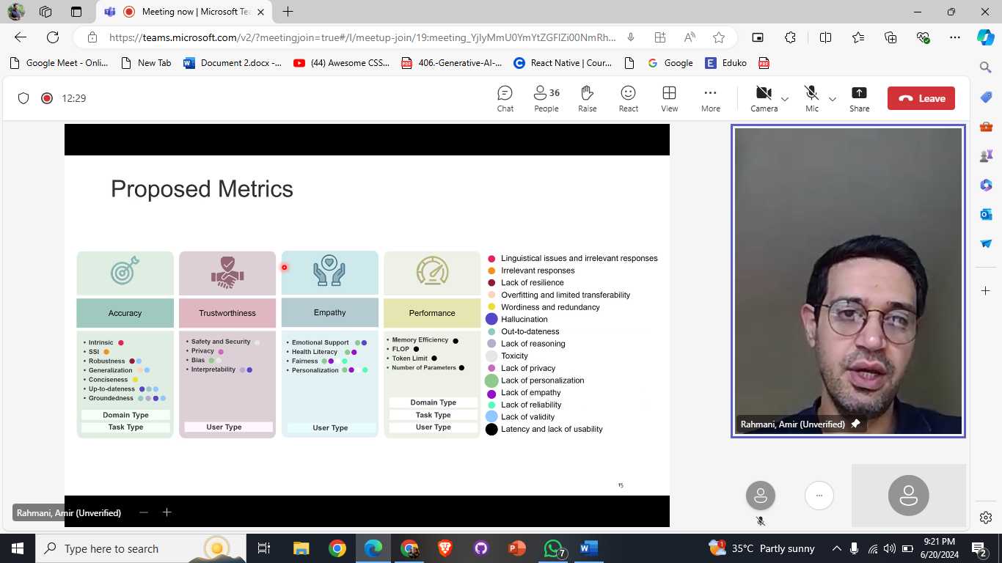

# Conversational Health Agents

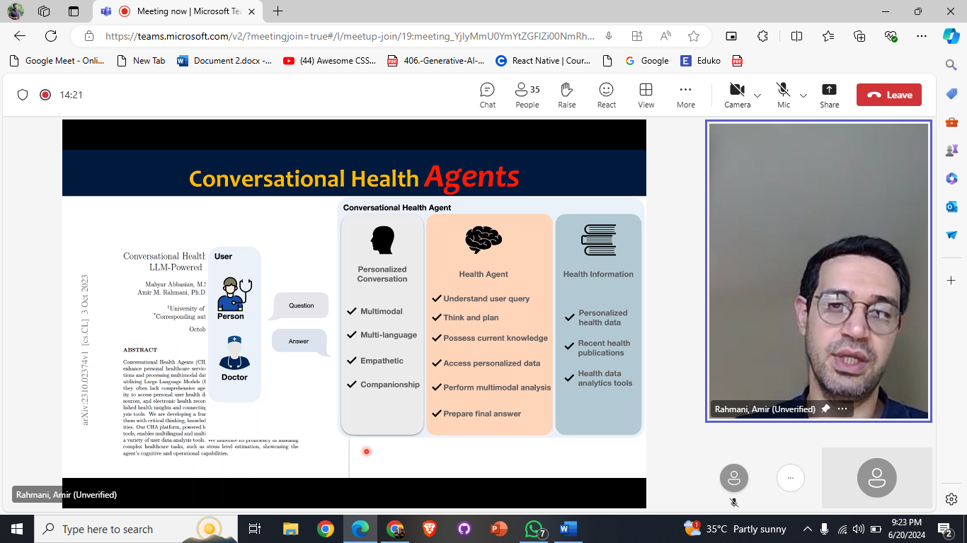

# Building Platform Open CHA

## 

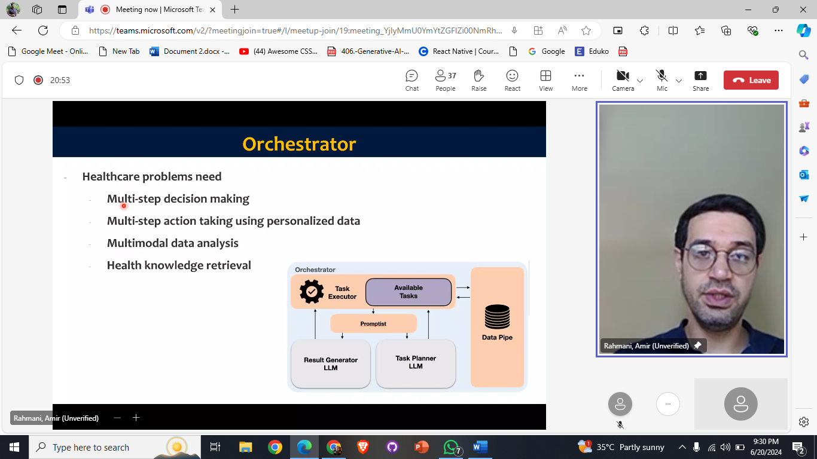

# Showing the Demo Video of Open CHA

Video Link: <https://youtu.be/PWxL_OgWGfE?si=Okpsgzb9JCYwPjjk>

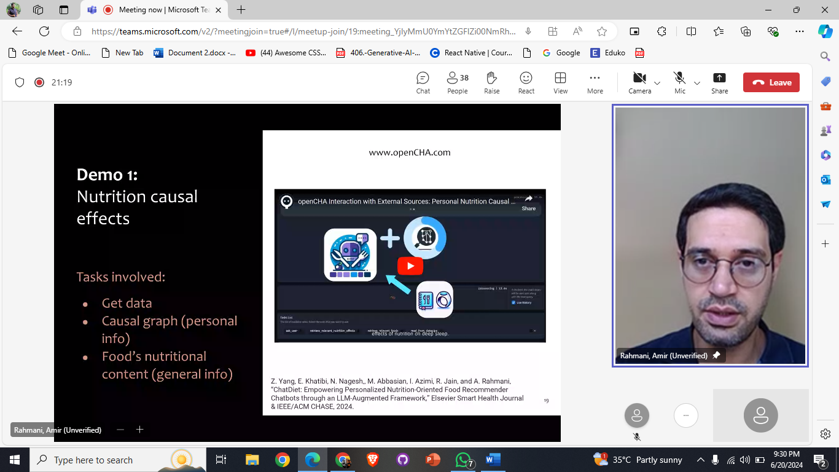

# Different Demos on Open CHA

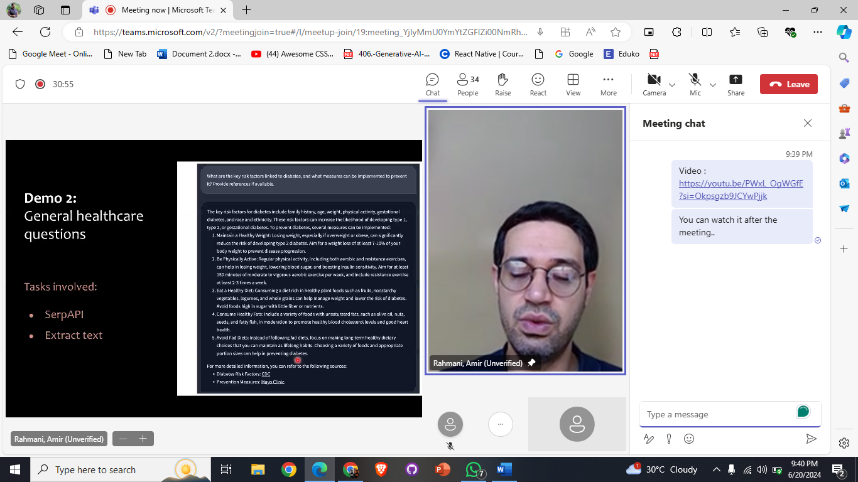

# Different Demos on Open CHA

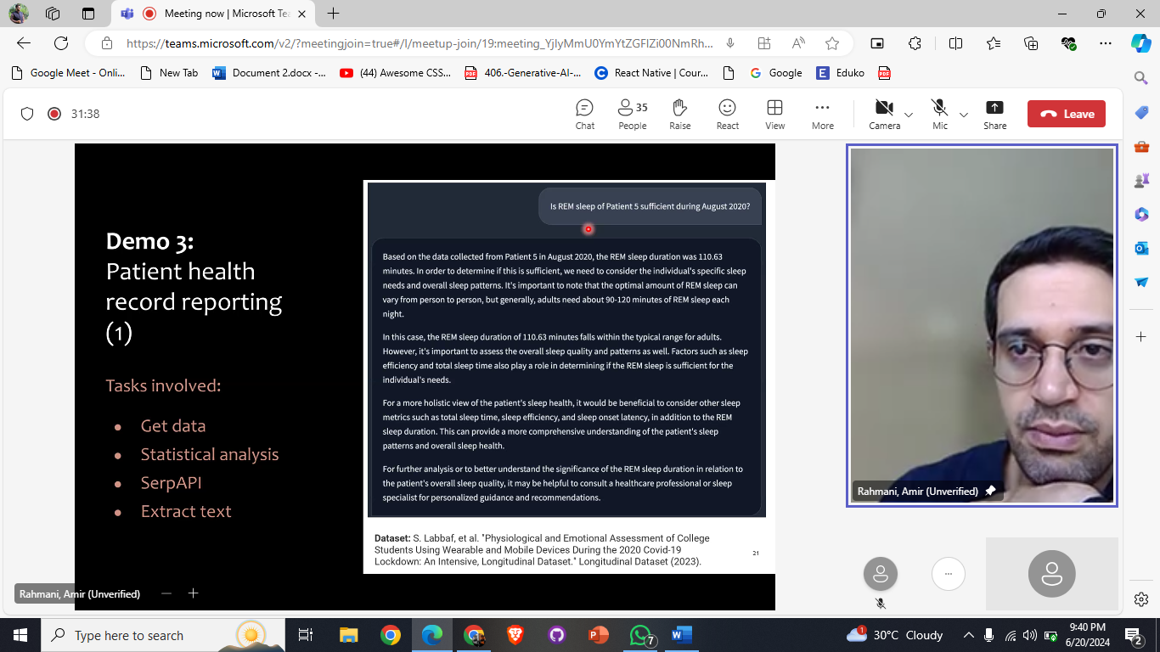

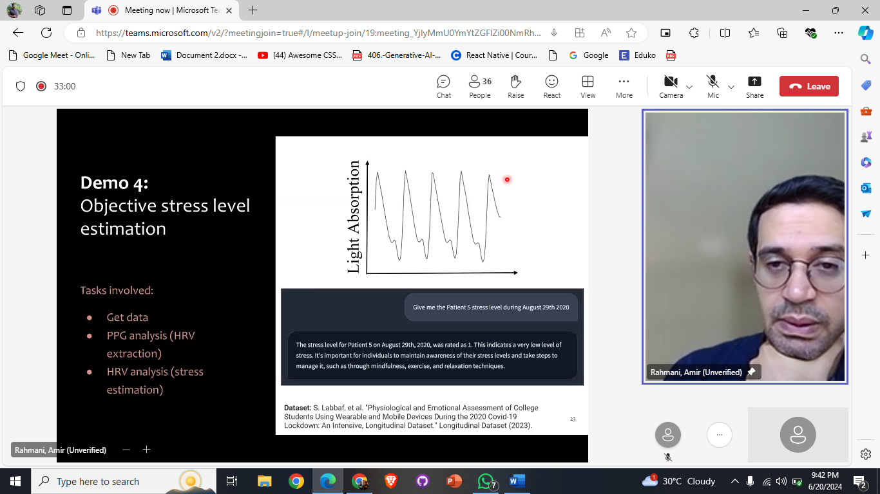

# Health Voice Assistant using NLP Technique Flow

## Pipeline Of How Voice Assistant Works

## 

# Case Study Classification Example

(base on Emotions)

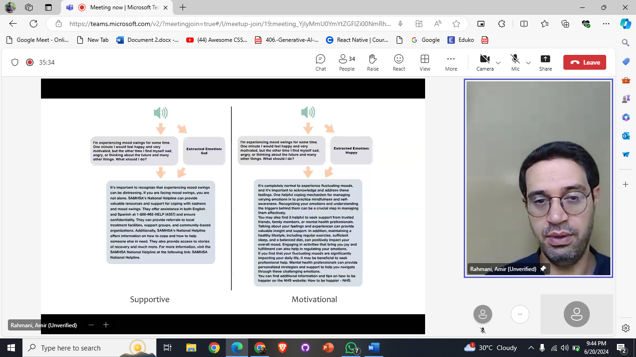

# Slight Talk on ALCM:

Its abbreviation, its pipeline, related work on it and some of its working demonstrations are as follow: 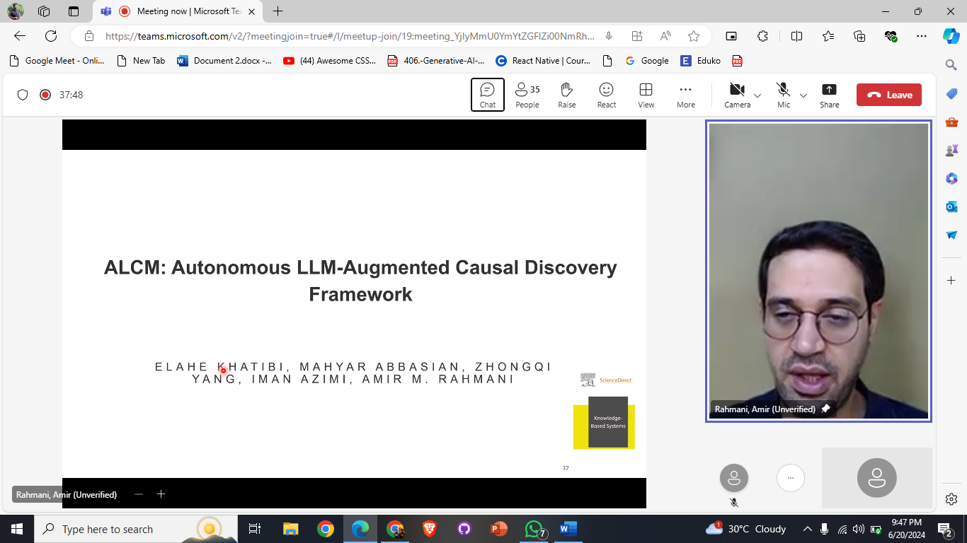

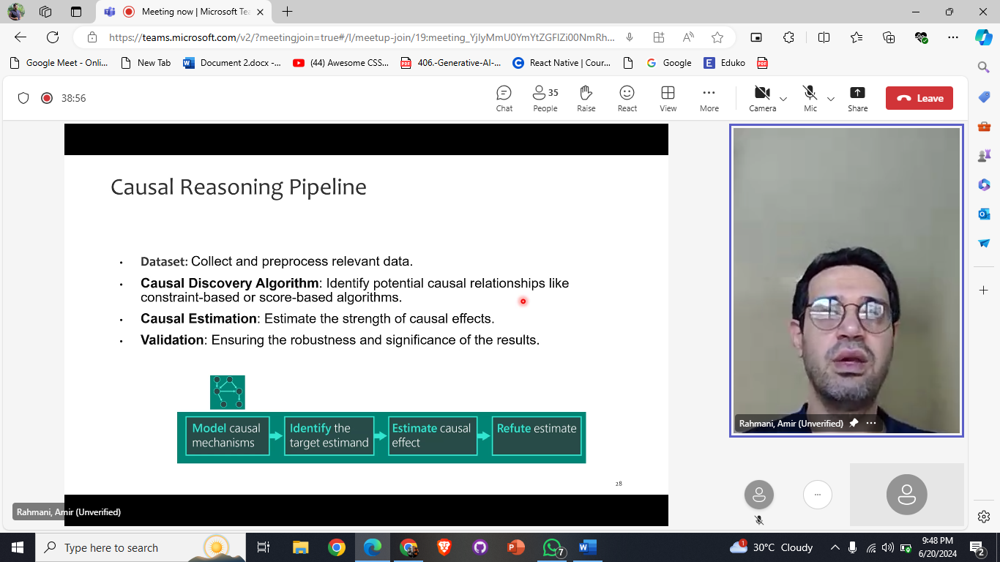

# Related Work on ALCM:

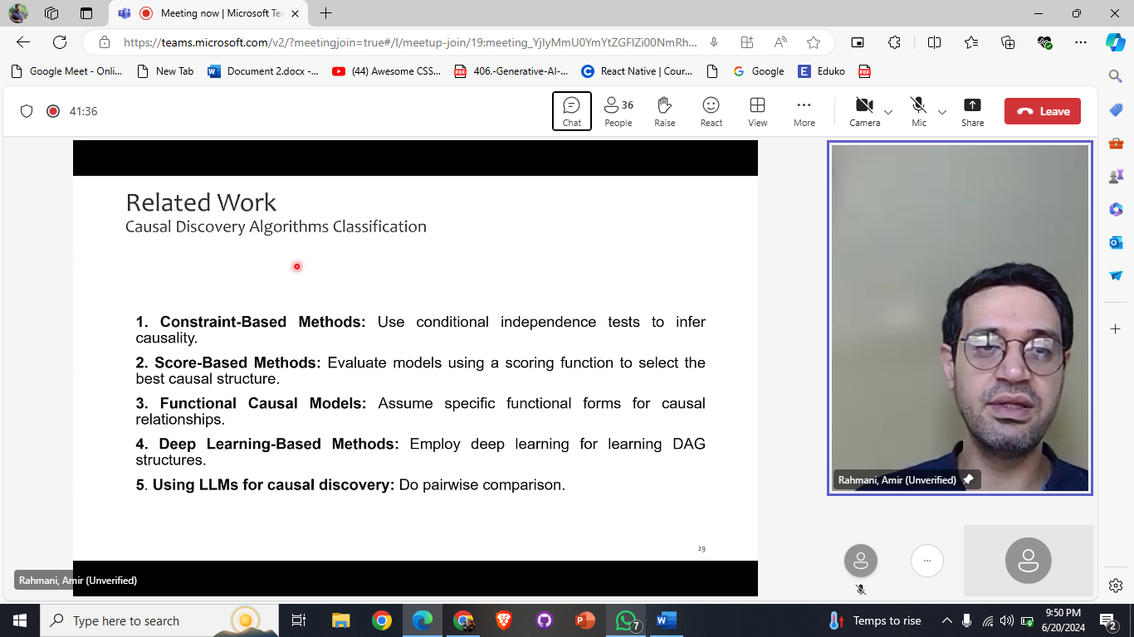

# 

# Framework of ALCM

# 

# Demonstrations

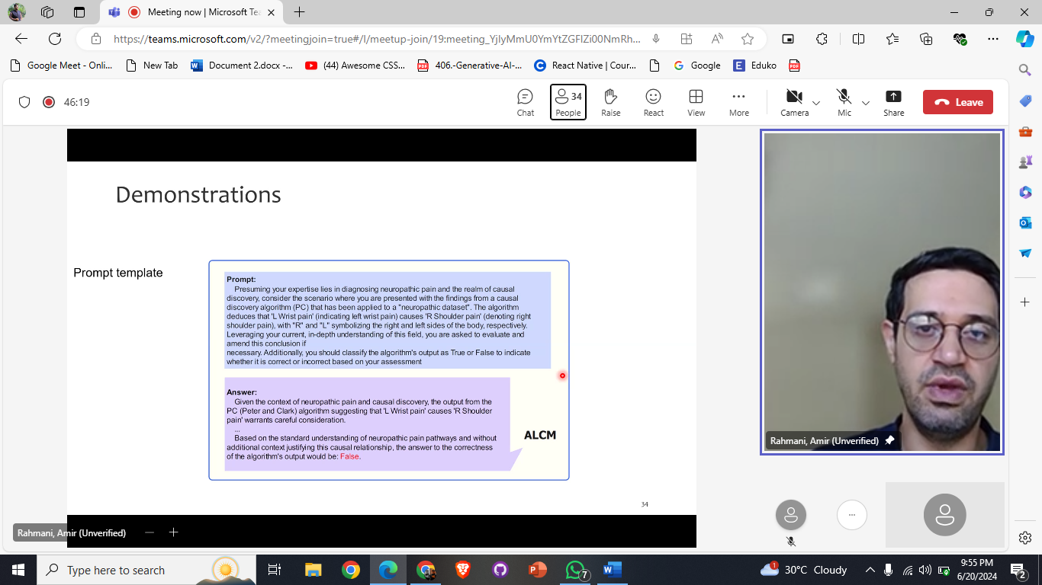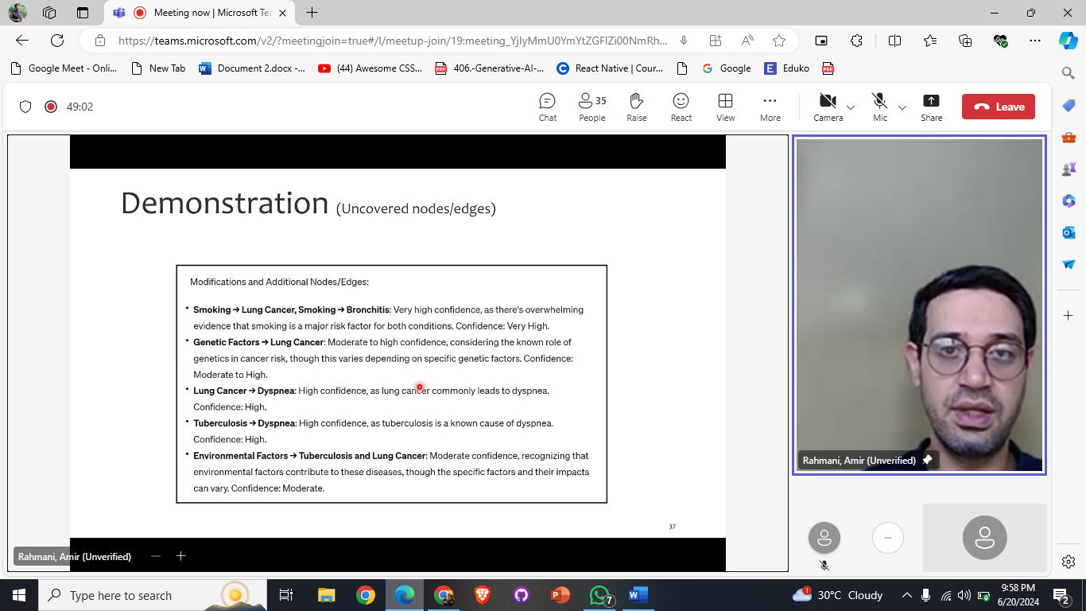

# Ending

